# Introduction

I am using NetBeans IDE 12.4. I have done from Stage 1 to Stage 5. In Stage 1 I have made sketch. And I saved it as PDF file. For the stage 2 I created a Java SE application project using name "DailyDriverManage". And it generated a file with "DailyDriverManage.java" which is the main file. After created i needed a jFrame window. Because we need a Gui interface so, we can input and output data and show tables. So, i give this JFrame name as "MainFrame". Now, I wanted to run this JFrame as Gui interface. So, I add codes about running this MainFrame in "DailyDriverManage.java" Main function. In the Stage 3 I made the working codes for the normal jtable and added the white table and the totals fields. And then coded for it. In the stage 4 I made the validation. If I write any letter in the numerical field. It will not take any latter while typing. For the Driver’s ID, it just takes only numbers. It does not take any float numbers(dot). And for the Amount, It takes numbers + dot(.) . And when it is going to save in both table then it transfer as float. For the stage 5, I completed all the buttons codes. And made the load and export codes.

# Design and Development

In stage 1 I made sketch. In that sketch there has shown a table and the fields and buttons.

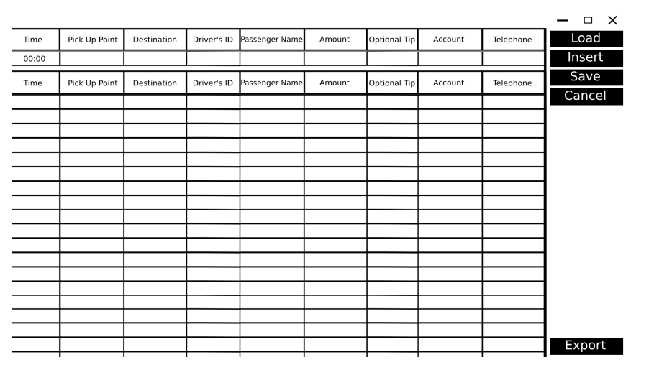

Here by the table for all the inserted data will be here.

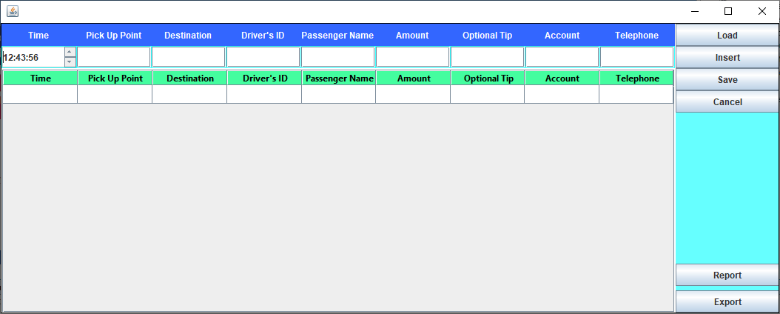

For the "Time" input field is one spinner box. And used custom codes.

Then I created a Table with those fileds text.

After the fields I created buttons.

Now for the Stage 3 i had to design a system where it will show like that output. So, I created with Textboxes for total summury and under those a table and placed those left side of that main table. And then gave the name to all buttons. And then created a class. And gave the name:"Functionalities". And then I created a inserting code there. Which input the inserted values in the main table and in the second table. After done the Maintable inserting code in that Functionalities.java i added it after click on insert button. Now for the same goes for the second Table. For this i have made two methods. First it check if the Driver Id is inserted before or not. Then if not then it will create a new row. And if it already was then it will be summing with new data. 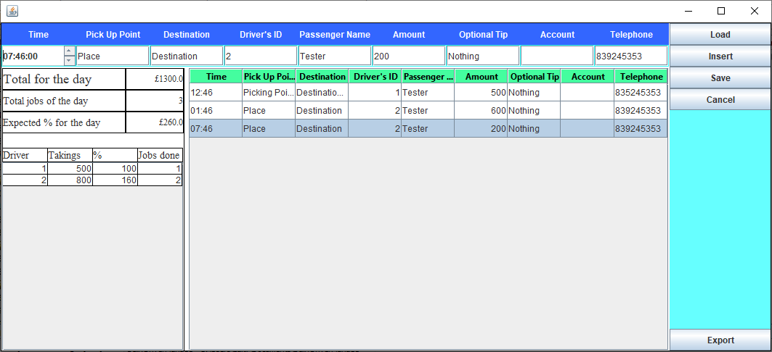

Now for the total info above that second Table. I made another function in the Functionalities.java. Called "TotalCount". After done the code. I settled it into the Insert Button code. Now there left for selecting from the table and cancel button. And the Saving button. So, First I did for selecting method. When we click on any cell. Of this row all will be retrieve into those Boxes. Now I coded for Cancel Button. What it does is if i change anything in the texboxes. Then it will reset all the changes. Now only left for saving. And then coded in the Save Button. Here these are done for basic working.

For the Stage 4. For these Driver's ID and Amount. I coded in both of those KeyTyped event. And for the Driver's ID it only takes numbers. And does not take any dot(.). So i have used checking method of typed char if that is digit or not. And the Amount Field takes both.

For the Stage 5. I coded for loading csv file. First it let the select the file. And then we get the filepath.So, after that we used a basic BufferedReader to read that file using that selected filepath. Added the rows in both tables. And also coded for the total. Now for the outputing as csv file. For that I coded in export Button. For the exporting the csv i made a boolean function in the Functionalities.java . And for the choosing folder to savepath i used showSaveDialog for JFileChooser. After get the save path then execute saving code with that path and the table. After the saved it shows a messagebox said "Saved csv to " that path.

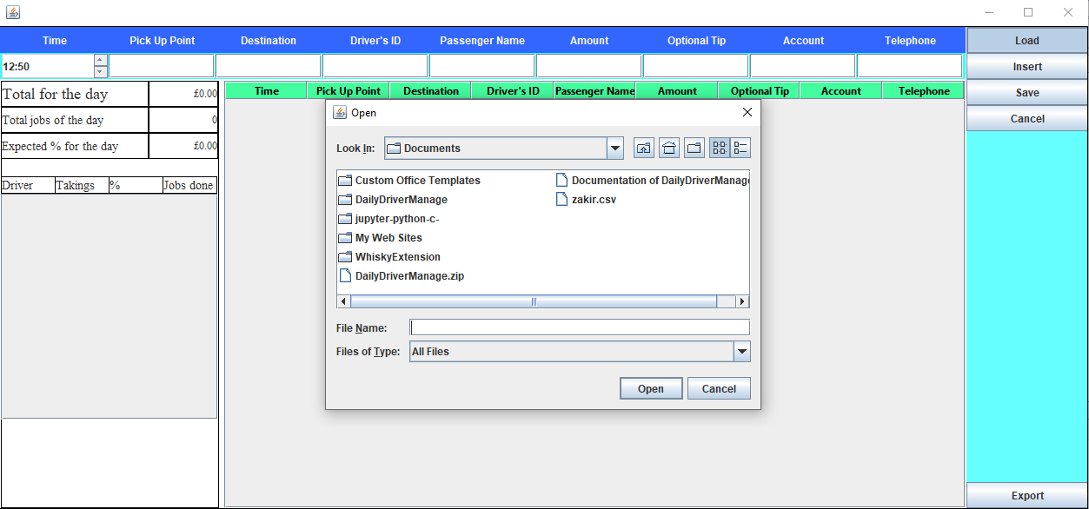

# Testing and Faults

* For the Driver ID I have used integer in both table and the input box. So, It will not take any dot(.) and others latter. And in the Driver ID input field I made a typing Event code. Coded for it.
* For the Amount I have used float in both table and the amount input box. Because it contains dot(.). Example. 45.75 . For these we cannot use any integer. So we had to insert as Float In the inserting code. Also I coded in this input box Typing Event. So, if he press dot and the numbers then it will store that char if he press others digit then this char will not be taken in that input box.

Without doing those people can enter any thing which they want. So, using those codes. We can block them.

# Self-evaluation

## Stage 1

I made the sketch. And then made the pdf. And this sketch has been used in Stage 2 to create in the java gui.

## Stage 2

I made as that stage 1 sketch just the design in the mainwindow gui. So, I think I did a good thing here.

## Stage 3

Here I coded a lot. I coded for the all buttons except the Load and the Export Button. And then coded for inserting . And then coded for the Totals and the Second table(Which is showing in the question). And also made a Functionalities.java class.

## Stage 4

I coded for validating the numerical and Float input boxes. And also coded for the both tables.

## Stage 5

I have coded for load and exporting as csv in both two buttons.

# Conclusions, further development and reflection

I got a lot of skills by making this project. Skills:

* I got a good knowledge about Java language
* Managed to know how to read csv and how to export as csv
* How to interact with jTable
* How to make a gui app
* How to make a standalone application
* Got a good knowledge about the Netbeans
* Got to know many events.
* Learnt how to validate
* Learnt how to insert
* Learnt how to select in jtable and retrieve those values into the input boxes
* Learnt spinner to use as Hour time.
* Learnt java language summing, dividing
* Learnt Object-Oriented
* Learnt how to use MS Excel files.
* Learnt how to clear.

To complete this I faced some problem:

* Creating Java Project.
* Designing in the gui.
* I had to know how to use jFrame.
* I had to connect the jFrame with the generated java file. And had to connect with that jFrame to there.
* Load csv
* Save as CSV
* Inserting into jTable. Which is basically add row.
* Retrieving selected row jTable into input boxes.
* Changing and saving.
* Canceling Button to reset which are changes.
* Doing sum in java code.
* Had to use currency icon as external
* Designing the jTable header

Some of these I tried myself and fixed. And some issue was tricky so I had to get help from online java documentation. And after fixed all those issue now the project is working perfect. It helped me to solve many upcoming issues. And also got many ideas. And now I think I know everything about jTable by fixing the issues. Now, I also can do many csv projects. If I had given more three months. Then I would have increasing many functions. And I could also add many buttons. And I could also make a new gui and then link to those into one main gui. Next I can make a printing system. Or I could make a saving system. Example, Saving as Microsoft office word file. Or excel file because we used Tables. Also I could add a export as PDF button. And I could use autocomplete search in Driver ID field. And then I would have made fee collections. I would have also made a lot of new gui. I would also use database. Also, I would store these inside online database. And I would made login gui. So, each users would have each functionalities. I would also use api system to use. I would also made Delete Button.